Waabanong Weekly Update
Delivered August 3, 2026
Week of July 27 to 31, 2026
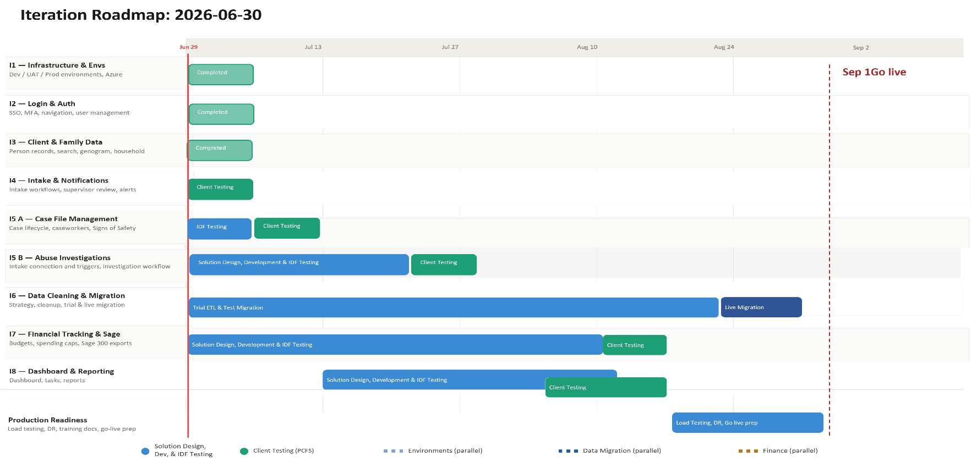

Iteration | Status | Current phase | Notes
I1 - System Infrastructure & Environments | Complete | Maintenance | Version bump
I2 - Login & Authorization | Complete | Maintenance | No changes this week
I3 - Client, Member & Family Data | Complete | Maintenance | Genogram search pagination added
I4 - Intake Management & Automated Notifications | Complete | Maintenance | No changes this week
I5 A - Case File Management & Signs of Safety | In Progress | Bug Fix | Case file UAT walkthrough held; two bugs found and fixed
I5 B – Abuse Investigations | In Progress | Development | Victim/offender selection logic and reporting refined
I6 - Data Migration | In Progress | Design | Contingency-budget need confirmed; timeline reassessment underway (no dev commits this week)
I7 - Financial Tracking & Exports for Sage | In Progress | Design | No activity this week
I8 - My Dashboard & Reporting | Not Started | — | No activity this week

Project Management & General
Weekly Progress
- Case file/ongoing-services UAT walkthrough held (Jul 28) with two new CRD testers (Rupen, Leanne) — full walkthrough of case creation, case notes, placements, legal status, signs of safety, face-to-face visits/AMR plans, documents, and the finance-tab stub
- Two bugs surfaced during the walkthrough and immediately queued for fixes:
- Child-in-care cases were opening under the parent instead of the child — needs a case-creation dropdown to select the child
- Reassigning a case's supervisor was incorrectly also changing the assigned director
- Follow-up items from the walkthrough: send test-environment access and a ticket-logging cheat sheet to the new testers; pull the PCFS organizational chart from Bamboo for test-user setup; coordinate a pretest session with CRDs and supervisors targeting Aug 7
- Rob flagged (Jul 30) that the FAMCare source data is rougher than anticipated, confirming the project's contingency budget will be drawn on for migration cleanup — exact amount still being assessed
- Go-live timeline confirmed slipping again, per Rob, for two reasons: slower-than-expected live-data access, and staggered UAT pushing back reporting/dashboard module design
I1 - System Infrastructure & Environments
Features
- Set up Development, Testing, and Production environments
Weekly Progress
- Version bump
I2 - Login & Authorization
Features
- Microsoft 365–based authentication
- User login
Weekly Progress
- No authentication changes this week.
I3 - Client, Member & Family Data
Features
- Centralized person records (children, adults, limited profiles)
  - Duplicate prevention
- Family and household structures
  - Multi-generation relationships
- Reciprocal relationship logic
- Global search across people and families
Weekly Progress
- Pagination added to genogram search results
I4 - Intake Management & Automated Notifications
Features
- Structured intake workflows with mandatory fields
- Intake status tracking and lifecycle
- Supervisor review and approval processes
- Ability to resolve intake without opening a case
- Escalation from intake to case creation
- Printable intake records
- Automated notifications:
  - In-application alerts
  - Defined external channels (email/messaging)
Weekly Progress
- No changes this week.
I5 A - Case File Management & Signs of Safety
Features
- Case file creation and lifecycle management
- Assignment of caseworkers and supervisors
- Case reassignment with approval
- Signs of Safety–aligned workflows, including:
  - Placement
  - Structured assessments
  - Safety goals and planning
  - Ongoing review checkpoints
- Visibility into historical and related cases
- Case notes for visits, services, and interactions
- Communication tracking across intake and case contexts
  - Document management: Person, Intake & Case
Weekly Progress
- Fixed Case File Placement Types not matching spec — corrected the placement-type dropdown list, addressing the bug found during the Jul 28 UAT walkthrough
- Clarified reassignment logic in CaseFileController for worker, supervisor, and director roles — addresses the director-reassignment bug found during the walkthrough
- Case file tab handling updated to use query parameters instead of hash fragments for more reliable URL/tab management
- Mandatory checklist modal actions streamlined: added "Close without Saving" and "Save & Close" buttons
- Fixed button title encoding issue in the supervisor review modal
I5 B – Abuse Investigations
Features
- Triggers and integration with Intake module
- Investigation workflow
- Investigation document management

Weekly Progress
- Consultation request linking added to review tasks; task-creation logic enhanced
- Active investigation logic improved for clearer, more accurate badge display
- Log entry display enhanced to prioritize the full message over the action badge for abuse reports
- Fixed sync logic to preserve alleged offenders during intake saves
- Improved victim/offender selection logic in the report-to-abuse modal — prevents a selected victim from also appearing as an offender option
I6 - Data Cleaning and Migration
Features
- Develop a data migration strategy from FAMCare into Waabanong
- Support PCFS as they perform data cleanup
- Execute trial data migrations in a sandbox environment
- Perform live data migration
Weekly Progress
- Rob confirmed the contingency budget will be needed for FAMCare migration cleanup, though the exact amount is still being assessed
- Timeline reassessment underway — go-live is slipping again due to slower-than-expected live-data access and staggered UAT pushing back other module work
I7 - Financial Tracking & Exports for Sage
Features (Potential scope may include)
- Intake-level emergency supports
- Case-level budgets
- Spending caps and approvals
- Export files to import into Sage 300
Weekly Progress
- No activity this week.
I8 - My Dashboard & Reporting
Features (Potential scope may include)
- My Dashboard (simple, quick reference to key items)
- Tasks & alerts
- Reporting (if required and not covered in other iterations)
Weekly Progress
- No activity this week.

